close all

clear

clc

%part 1

D=1;

alpha_0 = 0.5;

WEE = 8;

p_r = 1;

tau_s = 2E-3;

x = 1.2;

r_0 = 0.1;

r_max = 100;

sig = 0.5;

tau_r = 10E-3;

%%part 1a

n = 1;

for s = 0:0.001:1/WEE

s1(n) = s;

S = WEE*s;

f_S(n) = f(S,r_0,r_max,sig,x);

n = n+1;

end

f1=figure(1)

hold off

plot(s1, f_S)

% xlabel('s')

% ylabel('f(WEE*S)')

% title('part 1.a')

% saveas(f1, sprintf('1A.png'));

%now plot s(r)

n = 1;

clear s;

for r = 0:0.01:r_max

r1(n) = r;

D = 1;

s(n) = alpha_0*D*p_r*r*tau_s/(1+alpha_0*D*p_r*r*tau_s);

n = n+1;

end

hold on

plot(s,r1,'r--');

xlabel('s')

ylabel('r (Hz)')

xlim([0 0.015])

legend('r = f(S)', 's(r), synaptic strength', 'location', 'northwest')

title('part 1.a')

saveas(f1, sprintf('1A.png'));

%part b

dt=0.1e-3;

t=0:dt:20;

clear s;clear r;

s(1)=0;r(1)=0;

for i=2:length(t)

S=WEE*s(i-1);

r(i)=r(i-1)+dt*(-r(i-1)+f(S,r_0,r_max,sig,x))/tau_r;

s(i)=s(i-1)+dt*(-s(i-1)/tau_s+alpha_0*D*p_r*r(i)*(1-s(i-1)));

if t(i)>=10 && t(i)<=10.05

s(i)=0.05;

end

end

f2=figure(2)

plot(t,r)

xlabel('t(sec)')

ylabel('r(t)(Hz)')

title('part 1-b')

saveas(f2, sprintf('1B.png'));

f3=figure(3)

plot(t,s)

xlabel('t(sec)')

ylabel('s(t)')

title('part 1-b')

saveas(f3, sprintf('1B1.png'));

%% part 2

tau_D=250e-3;

p_r=0.2;

r_0=0.1;

alpha_0=0.5;

WEE=60;

clear s; clear r;

n = 1;

for s = 0:0.001:1/WEE

s1(n) = s;

S = WEE*s;

f_S(n) = f(S,r_0,r_max,sig,x);

n = n+1;

end

f4=figure(4)

hold off

plot(s1, f_S)

n = 1;

clear s;clear r;

for r = 0:0.01:r_max

r1(n) = r;

D = 1/(1+p_r*r*tau_D);

s(n) = alpha_0*D*p_r*r*tau_s/(1+alpha_0*D*p_r*r*tau_s);

n = n+1;

end

hold on

plot(s,r1,'r--');

xlim([0 0.003])

xlabel('s')

ylabel('r (Hz)')

legend('r = f(S)', 's(r), synaptic strength', 'location', 'northwest')

title('part 2-a')

saveas(f4, sprintf('2A.png'));

%part 2-b

dt=0.1e-3;

t=0:dt:20;

clear s;clear r;

s(1)=0;r(1)=0;D(1)=1;

for i=2:length(t)

S=WEE*s(i-1);

r(i)=r(i-1)+dt*(-r(i-1)+f(S,r_0,r_max,sig,x))/tau_r;

D(i) =D(i-1)+dt*(((1-D(i-1))/tau_D)-p_r*D(i-1)*r(i));

s(i)=s(i-1)+dt*(-s(i-1)/tau_s+alpha_0*D(i)*p_r*r(i)*(1-s(i-1)));

if t(i)>=10 && t(i)<=12

s(i)=0.002;

end

end

f5=figure(5)

plot(t,r)

xlabel('t(sec)')

ylabel('r(t)(Hz)')

title('part 2-b')

saveas(f5, sprintf('2B.png'));

f6=figure(6)

plot(t,s)

xlabel('t(sec)')

ylabel('s(t)')

title('part 2-b')

saveas(f6, sprintf('2B1.png'));

%% part 3

p_r=0.5;

WEE=35;

r_0=-0.1;

clear s; clear r;

n = 1;

for s = 0:0.001:1/WEE

s1(n) = s;

S = WEE*s;

f_S(n) = f(S,r_0,r_max,sig,x);

n = n+1;

end

f7=figure(7)

hold off

plot(s1, f_S)

n = 1;

clear s;clear r;

for r = 0:0.01:r_max

r1(n) = r;

D = 1/(1+p_r*r*tau_D);

s(n) = alpha_0*D*p_r*r*tau_s/(1+alpha_0*D*p_r*r*tau_s);

n = n+1;

end

hold on

plot(s,r1,'r--');

xlim([0 0.003])

xlabel('s')

ylabel('r (Hz)')

legend('r = f(S)', 's(r), synaptic strength', 'location', 'northwest')

title('part 3-a')

saveas(f7, sprintf('3A.png'));

dt=0.1e-3;

t=0:dt:20;

clear s;clear r;

s(1)=0;r(1)=0;D(1)=1;

for i=2:length(t)

S=WEE*s(i-1);

r(i)=r(i-1)+dt*(-r(i-1)+f(S,r_0,r_max,sig,x))/tau_r;

D(i) =D(i-1)+dt*(((1-D(i-1))/tau_D)-p_r*D(i-1)*r(i));

s(i)=s(i-1)+dt*(-s(i-1)/tau_s+alpha_0*D(i)*p_r*r(i)*(1-s(i-1)));

if t(i)>=10 && t(i)<=10.6

s(i)=0.002;

end

end

f8=figure(8)

plot(t,r)

xlabel('t(sec)')

ylabel('r(t)(Hz)')

title('part 3-b')

saveas(f8, sprintf('3B.png'));

f9=figure(9)

plot(t,s)

xlabel('t(sec)')

ylabel('s(t)')

title('part 3-b')

saveas(f9, sprintf('3B1.png'));

%%part 3-c

dt=0.1e-3;

t=0:dt:20;

clear s;clear r;

r(1)=9;D(1)=1/(1+p_r*r(1)*tau_D);s(1)=alpha_0*D(1)*p_r*r(1)*tau_s/(1+alpha_0*D(1)*p_r*r(1)*tau_s);

for i=2:length(t)

S=WEE*s(i-1);

r(i)=r(i-1)+dt*(-r(i-1)+f(S,r_0,r_max,sig,x))/tau_r;

D(i) =D(i-1)+dt*(((1-D(i-1))/tau_D)-p_r*D(i-1)*r(i));

s(i)=s(i-1)+dt*(-s(i-1)/tau_s+alpha_0*D(i)*p_r*r(i)*(1-s(i-1)));

if t(i)>=10 && t(i)<=10.6

s(i)=0.002;

end

end

f10=figure(10)

plot(t,r)

xlabel('t(sec)')

ylabel('r(t)(Hz)')

title('part 3-c')

saveas(f10, sprintf('3C.png'));

f11=figure(11)

plot(t,s)

xlabel('t(sec)')

ylabel('s(t)')

title('part 3-c')

saveas(f11, sprintf('3C1.png'));

%% part 4

tau_D=0.125

alpha_0=0.25;

p_r=1;

clear s; clear r;

r(1)=9;D(1)=1/(1+p_r*r(1)*tau_D);s(1)=alpha_0*D(1)*p_r*r(1)*tau_s/(1+alpha_0*D(1)*p_r*r(1)*tau_s);

n = 1;

for s = 0:0.001:1/WEE

s1(n) = s;

S = WEE*s;

f_S(n) = f(S,r_0,r_max,sig,x);

n = n+1;

end

f12=figure(12);

hold off

plot(s1, f_S)

n = 1;

clear s;clear r;

for r = 0:0.01:r_max

r1(n) = r;

D = 1/(1+p_r*r*tau_D);

s(n) = alpha_0*D*p_r*r*tau_s/(1+alpha_0*D*p_r*r*tau_s);

n = n+1;

end

hold on

plot(s,r1,'r--');

xlim([0 0.003])

xlabel('s')

ylabel('r (Hz)')

legend('r = f(S)', 's(r), synaptic strength', 'location', 'northwest')

title('part 4-a')

saveas(f12, sprintf('4A.png'));

dt=0.1e-3;

t=0:dt:20;

clear s;clear r;

s(1)=0;r(1)=0;D(1)=1;

for i=2:length(t)

S=WEE*s(i-1);

r(i)=r(i-1)+dt*(-r(i-1)+f(S,r_0,r_max,sig,x))/tau_r;

D(i) =D(i-1)+dt*(((1-D(i-1))/tau_D)-p_r*D(i-1)*r(i));

s(i)=s(i-1)+dt*(-s(i-1)/tau_s+alpha_0*D(i)*p_r*r(i)*(1-s(i-1)));

if t(i)>=10 && t(i)<=10.6

s(i)=0.002;

end

end

f13=figure(13);

plot(t,r)

xlabel('t(sec)')

ylabel('r(t)(Hz)')

title('part 4-b')

saveas(f13, sprintf('4B.png'));

f14=figure(14)

plot(t,s)

xlabel('t(sec)')

ylabel('s(t)')

title('part 4-b')

saveas(f14, sprintf('4B1.png'));

Function F is defined as:

function fout = f(S,r_0,r_max,sig,x);

if S < 0

fout = r_0;

else

fout = r_0 + r_max*(S^x)/(S^x+sig^x );

end

1.a

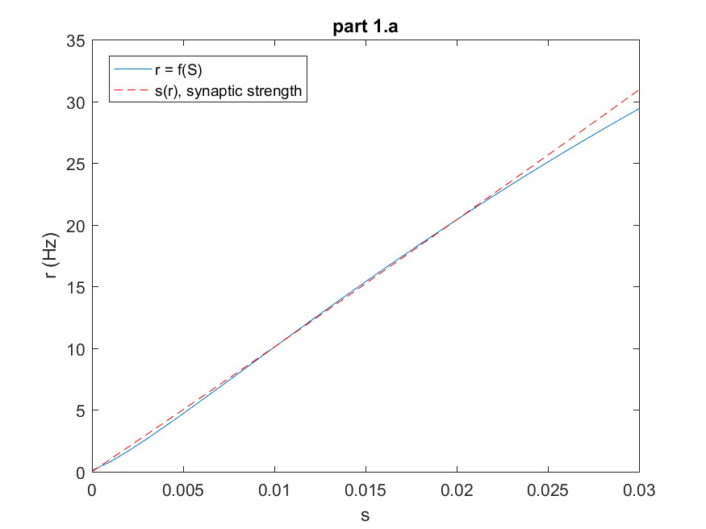

1.b

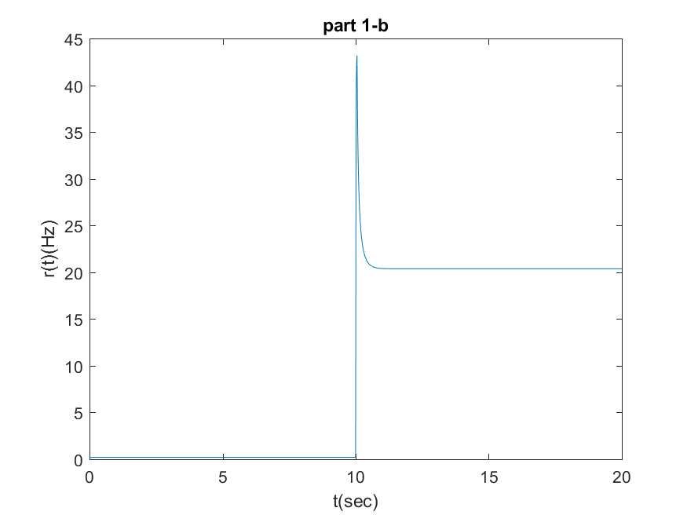

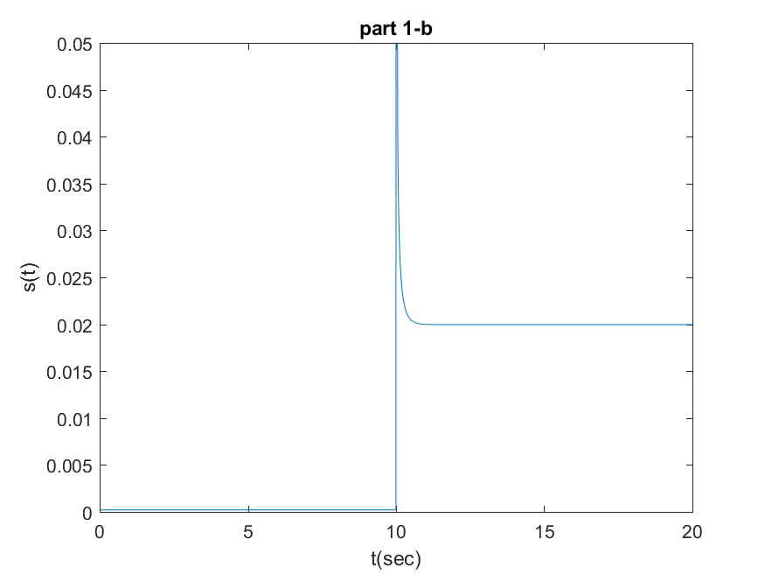

In Figure part 1.a, I can see that the graph contains three fixed points that the point (r=10,s=0.012) is considered as a fixed unstable point and other two considered as stable firing rates where the system settles. Before the transient input, the system resides at a stable fixed point, corresponding to a zero firing rate and synaptic strength. The external input (s_in) disrupts the system's balance. This can cause the firing rate to move away from the initial stable state, potentially towards an unstable fixed point. Since the fixed point is unstable, the system won't stay there. It might momentarily reach a peak firing rate near this point due to the influence of the input. As the input fades away, the system's dynamics will pull it towards another stable fixed point with a different firing rate and synaptic strength (r=22,s=0.02).

2.a

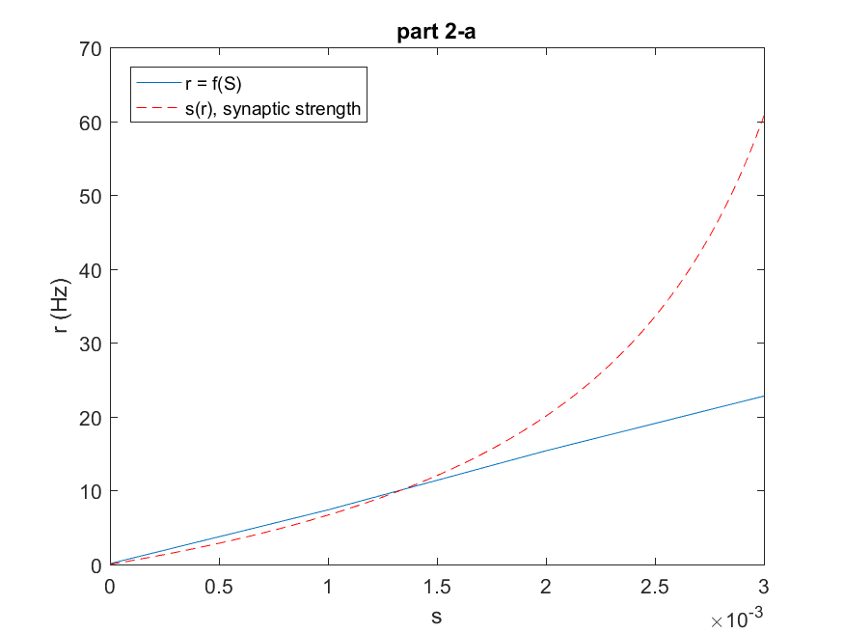

2.B

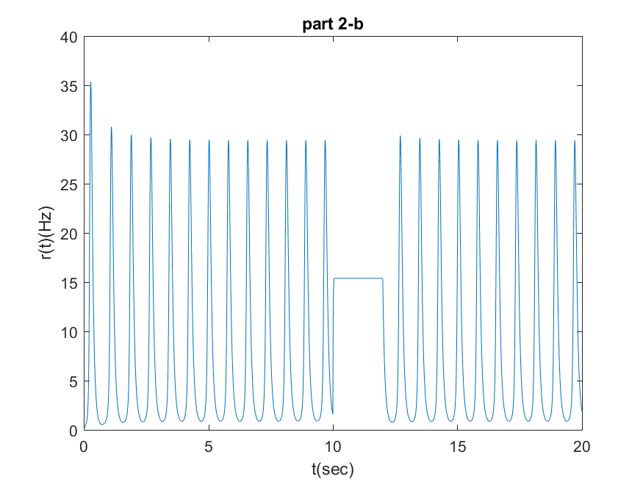

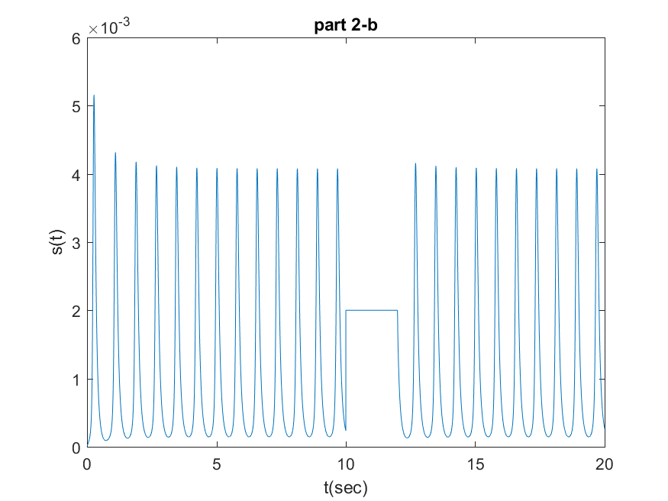

In this part I can unstable fixed points. It is like the depression destabilized the states and small deviations from the equilibrium point will push the system away, leading to oscillations. I can see that the transient input causes stable temporary state but after that, it returned to initial state and becomes oscillatory once again.

3.a

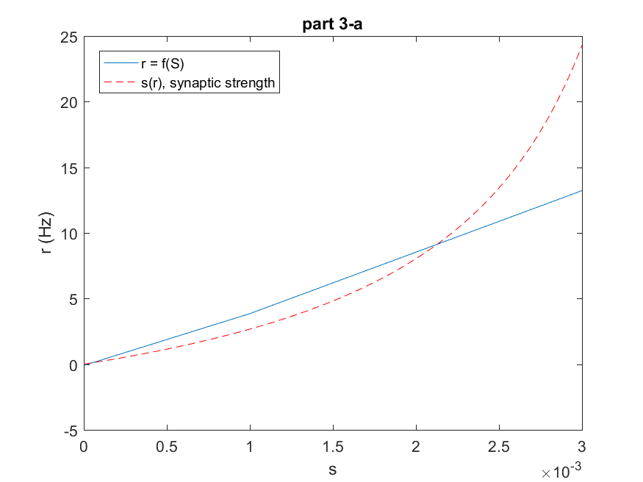

3.B

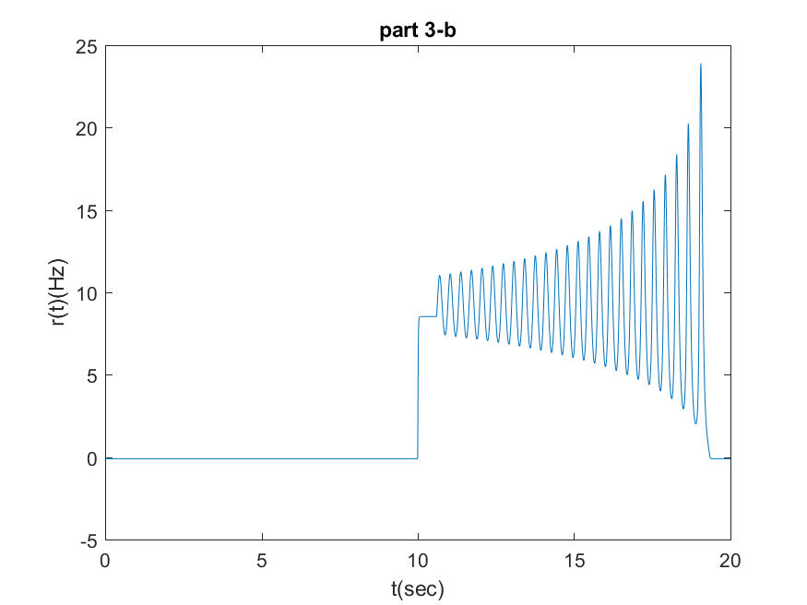

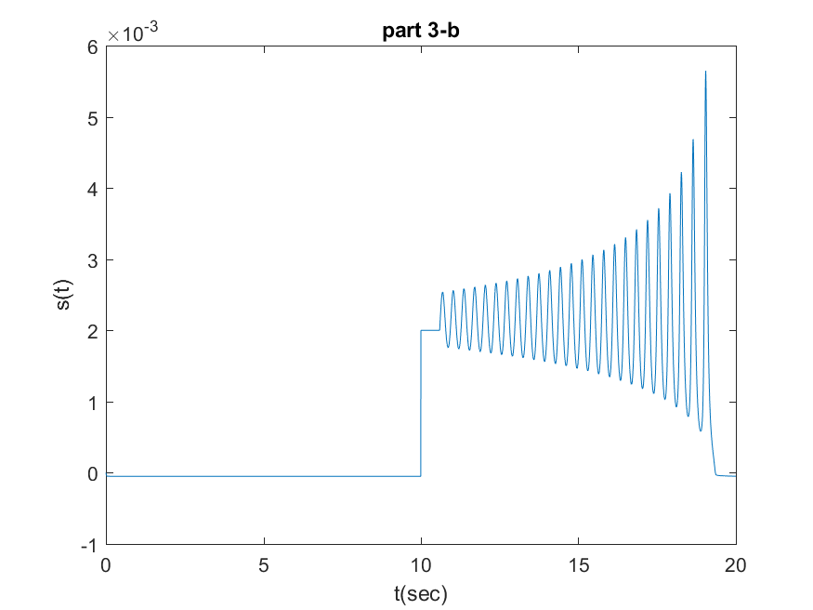

The system starts in a state with a negative baseline firing rate (P_r) implying that the neurons are not firing much initially. Due to depression dynamics (lower synaptic strength s caused by depression parameter D), the synaptic connections are weak initially. When a transient input is applied, it slightly increases the firing rate (r) from its zero-rate state and the increased influence of firing rate on synaptic strength (p_r) could lead to a positive feedback loop. As the firing rate (r) slightly increases from the zero-rate state, the synaptic strength (s) also increases. This increase in s could further boost the firing rate (r) due to the stronger synaptic connections. After the transient input is removed the system returned to its first initial state due to the negative baseline firing rate​ and depression dynamics.

3.C

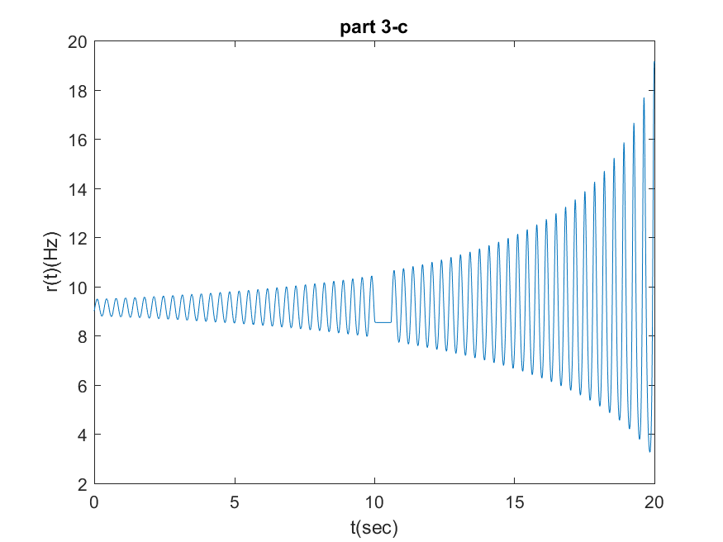

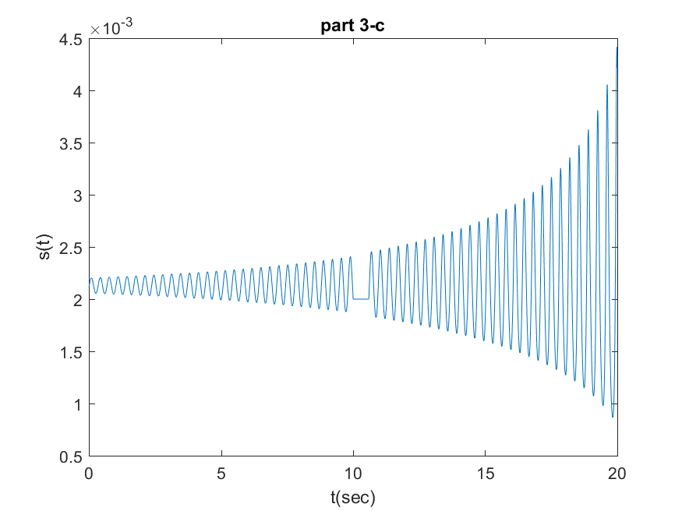

Clearly the system is unstable the transient input causes system temporary stablity for a the few applied seconds but The system has a positive feedback loop between firing rate and synaptic strength, where an increase in firing rate leads to an increase in synaptic strength, which in turn further increases the firing rate. This positive feedback can amplify small fluctuations, leading to oscillations with increasing amplitude.

4.a

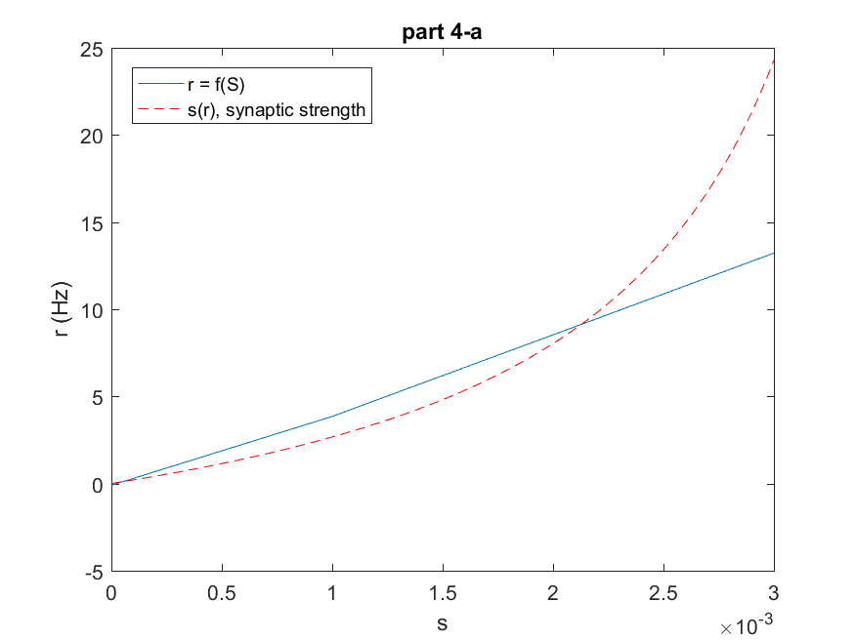

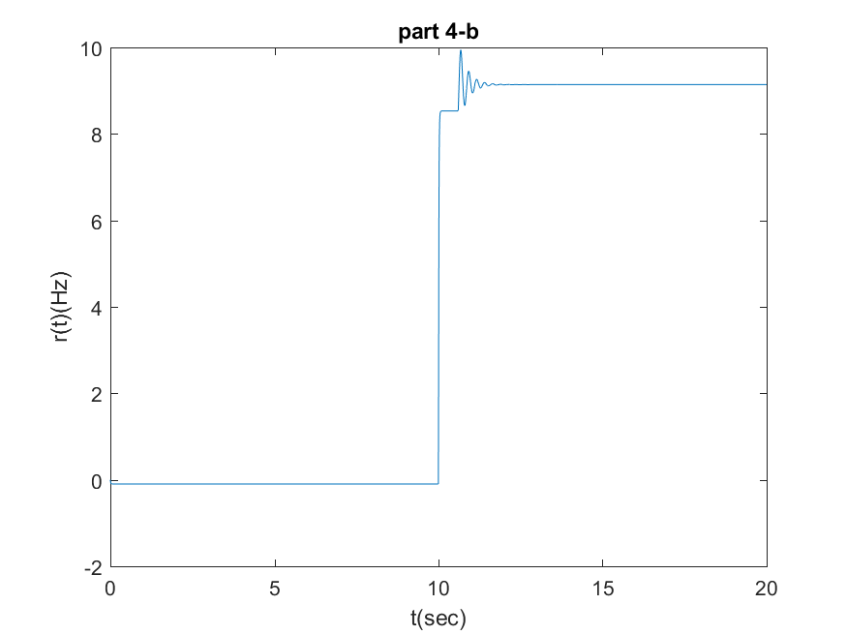

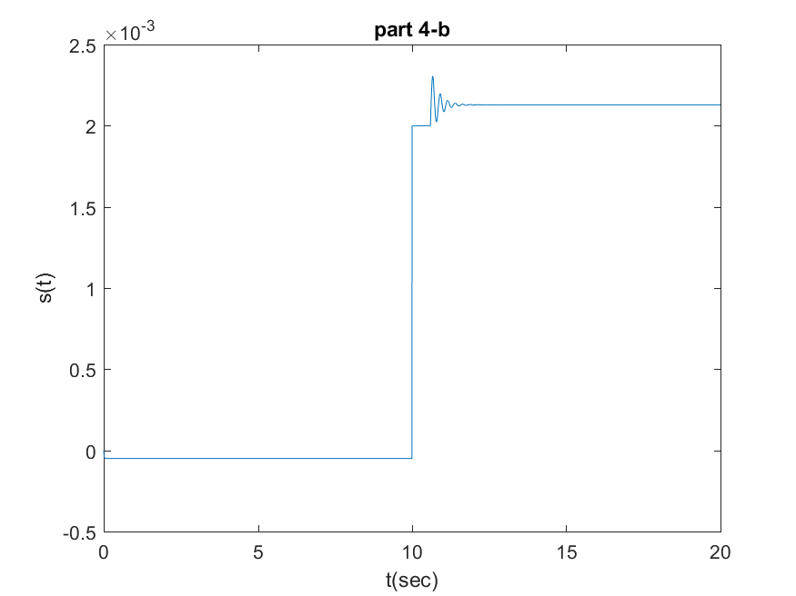

By halving tau_D, depression acts faster. This strengthens the negative feedback mechanism, reducing the time it takes for synaptic strength to decrease after a rise in firing rate. Reducing alpha_0 weakens the initial impact of firing rate on synaptic strength. This weakens the initial positive feedback and makes the system less sensitive to fluctuations. Therefore system settled in a stable state after some small oscilations.